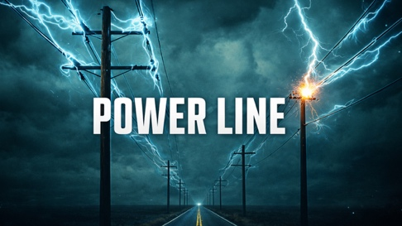
The Holy Spirit Derrick Nichols, LifeSpring Church
7.5.2026

1. The Holy Spirit is the ______________ _______________ of the _______________.
Matthew 28:19
Matthew 3:16-17
2. The same Holy Spirit that ___________ Jesus back to life is the
__________ Holy Spirit that ___________ every believer.
Romans 8:9-11
3. The ________ __________ glorifies the Son, the __________
glorifies the Son, and the ________ glorifies the Father.
John 17:1-4
John 16:13-14
The Holy Spirit __________ us to Christ and ___________ God’s
saving work to ____________ who _________ their faith in Christ.
John 16:8
John 3:1-7

